M8.2 Assignment
Course: CSD310 – 340A
Prepared By: Mirach Erkol
Date of Report: 11/30/2025

https://github.com/Mikey5007/csd-310.git

M8.2 Assignment: Screenshot 1, Output with CLI
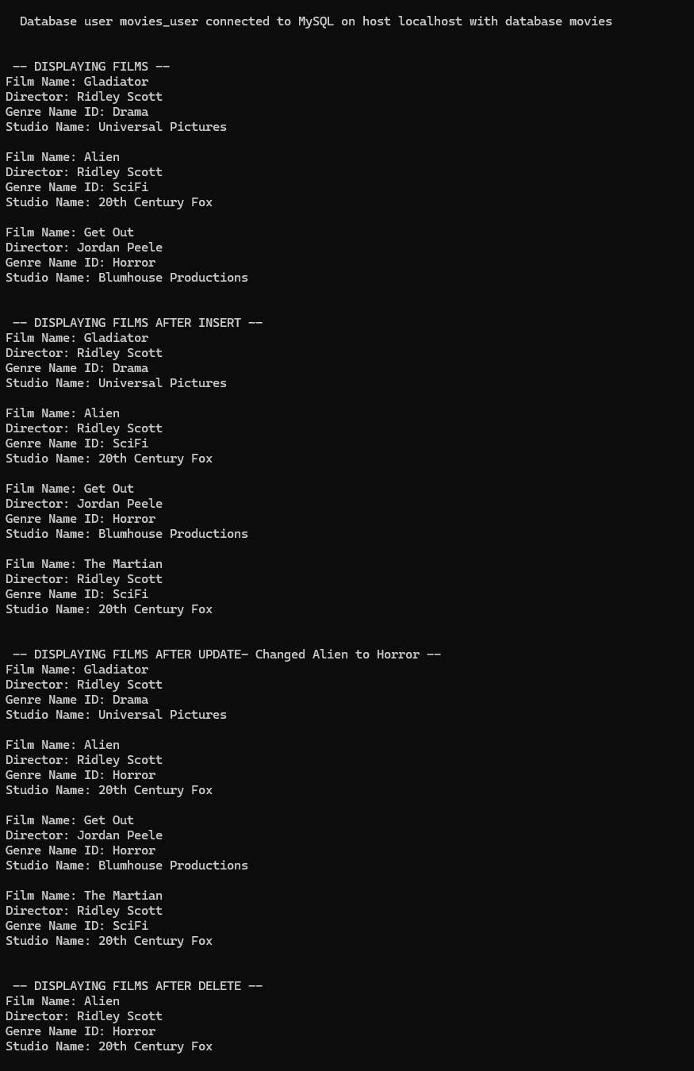
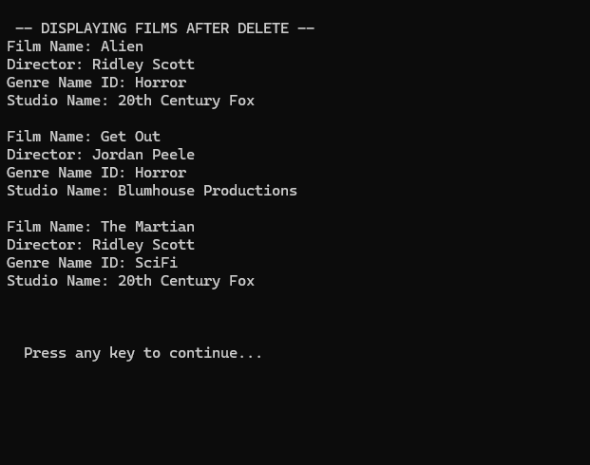

M8.2 Assignment: Screenshot 2, Output on Pycharm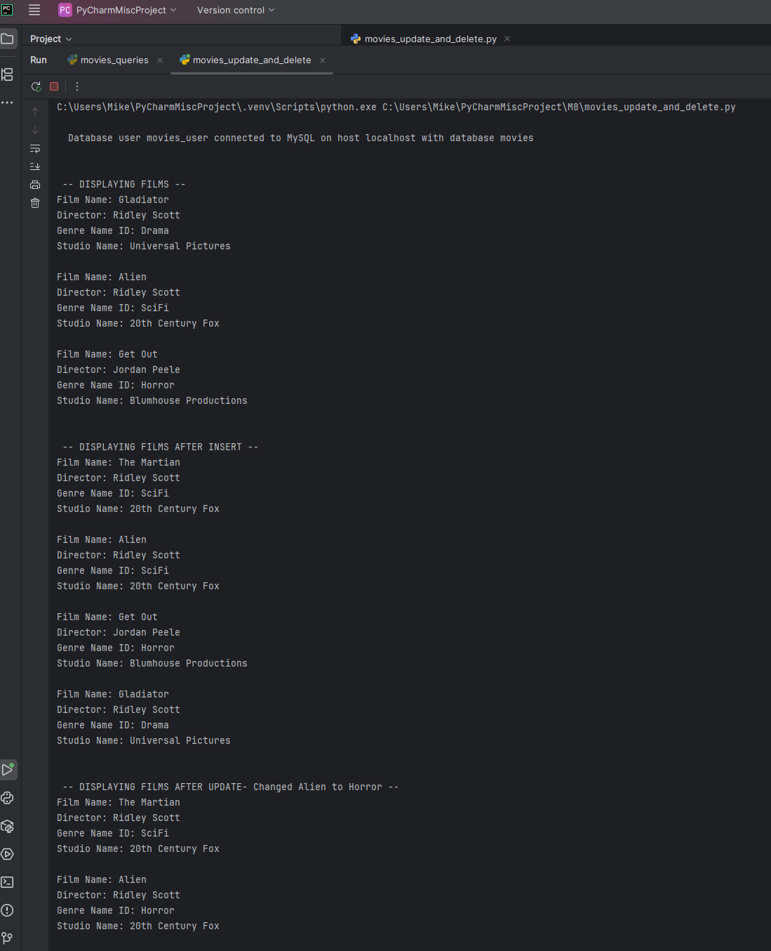
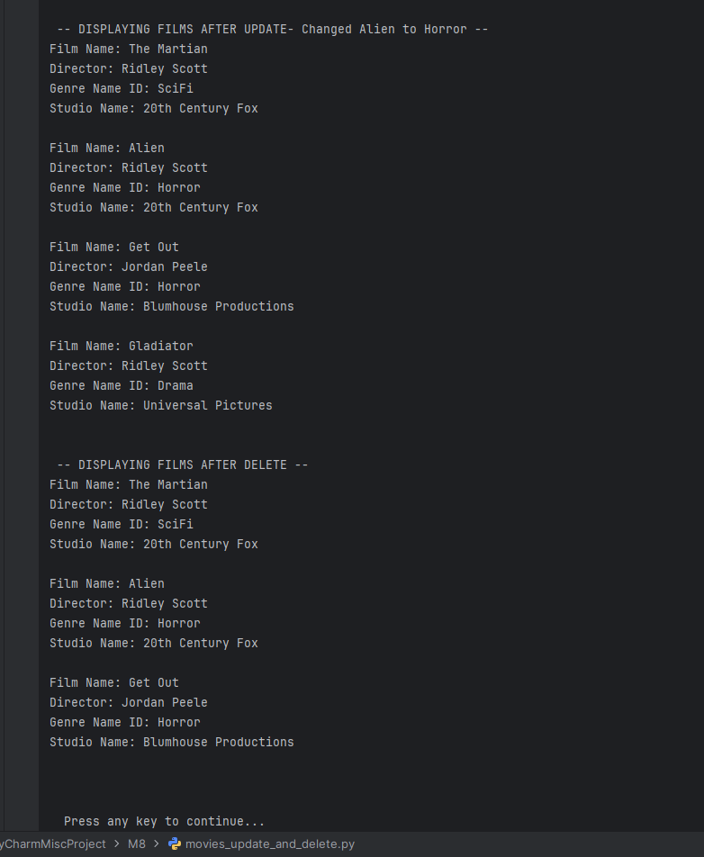Mikey5007/csd-310: CSD

